

**New Maudsley Training**

**EATING DISORDERS**

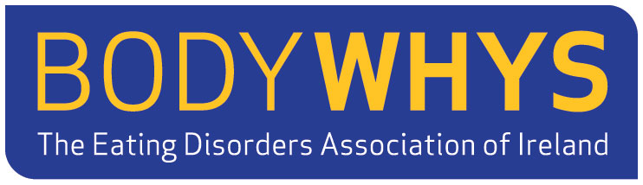

*Specialist Training by:***GILL TODD RMN MSc**

**Date: Saturday 1st and Sunday 2nd April 2017  
Venue Sponsored by:   
Clayton Hotel, Leopardstown, Co. Dublin**

Registration Day 1 @ 9am *(pre-registration necessary)*  
Course 9:30am – 4:30pm each day

**Cost: €100 Family/Carers €150 Professionals**

***Subjects covered will include:***

* Explore how family relationship issues contribute to   
  maintaining the Eating Disorder.
* Learn about the psychology of an Eating Disorder
* Practice makes perfect - we will practice the necessary   
  communication skills to help improve your Loved Ones' self-esteem.
* Pre reading: ‘Skills-based Learning for Caring for a Loved One   
  with an Eating Disorder’ *Pub. Routledge 2007.*

For further information and pre-registration, contact:  
[**newmaudsleyworkshop@gmail.com**](mailto:newmaudsleyworkshop@gmail.com)

*Supported by:*

**2 Day Family / Carers’ Workshop**

**Skills Based Caring in Eating Disorders**